Contents

1. INTRODUCTION 3

1.1. Problem Elucidation and Statement 3

1.2. Project Aim 4

1.3. Project Objectives 4

2. LITERATURE REVIEW 5

2.1. Literature Review Part 1: Initial investigation for the project/problem context area 5

2.2. Literature Review Part 2 – Similar solution 9

3. PROJECT PLAN AND REQUIREMENTS SPECIFICATION 14

3.1. Stakeholder Identification 14

3.2. Requirement Gathering Methodology 15

3.3. Prioritisation Strategy 22

3.4. System Requirement Specification 0

3.5. Software Life Cycle Methodology 1

3.6. Implementation Plan 3

3.6.1. Work Breakdown Structure 3

3.6.2. Gantt Chart 5

3.6.3. Resource Identification 7

3.7. Verification Plan 8

3.8. Validation Plan 12

4. PROJECT RISK ASSESSMENT 16

4.1. Risk Assessment 16

4.2. Mitigation Strategy 17

5. INITIAL FUNCTIONAL PROTOTYPE 19

5.1. Risk to be assessed and Design Artefacts 19

6. Requirement Control 24

Final Requirements 24

Dropped requirements 26

Modified requirements 26

Added Requirements 27

Modification to the original project plan 28

7. System Design 30

7.2 Interface Design 30

Initial GUI sketch 30

User interaction Wireframes 31

8. System Implementation 32

9. System Verification 32

10. System Validation 32

11. Conclusion & Reflection 33

Bibliography 34

Appendix 1 36

Appendix 2 37

Appendix 3 39

Appendix 4 54

Appendix 5 59

# INTRODUCTION

## Problem Elucidation and Statement

When we are comfortably living at family/parents’ home we never think about renting a house or the living costs that are required, but when we have to move out or find a place of our own to rent and live in, then we start looking for information. For first time renters it is very difficult to know where to begin and who to ask, even if you have been renting a property but want to relocate to a different country or town, it is very dauting and scary. The biggest issue is that there are limited resources out there with the relevant information to let people decide what area is good or what area is affordable to rent and live in. to find all this information, people have to look in different locations, review pages and even local council website to get information about the area, even then the information provided there, are very limited to give people an idea of the town or the city. Whether you are relocating from one town to another or to another country, you always worry, and many people tend to get moving anxiety and that is due to not knowing what type of area or house you are moving into.

“In a recent poll, two thirds of people voted moving to a new house top of their stress list”(Telegraph Media Group Limited, 2019)

“It's one of life's most stressful experiences, and it's because it involves having to cope with change,” explains Nicky Lidbetter, chief executive of charity Anxiety UK. “Moving to a new house represents a transition in life, it’s about changes and unfamiliarity and for many people that causes stress and anxiety. Most of us like familiarity, routine and order. When you're moving, you have none of those. Plus, it causes a ripple effect of change throughout your life. You're not just changing your home and getting to know the new one, you might be in a new area, you have to find new schools for your children, take on a new commute to work, find a new GP and dentist.” (Telegraph Media Group Limited, 2019)

My proposed solution is to develop an app that will provide relevant information obtained through crowdsourcing (such as if schools and shopping malls are nearby, if the workplace is easy to commute to) to help ease and prevent stress people get when thinking about moving and renting a new house. There is a large gap in the market for this as some estate agents provide only limited information about the location and the living cost for the property.

The Project idea is to develop a mobile application that will allow users to get information for the area or if the user has an account created, they will be able to leave feedback and information upon the area they live in.

## Project Aim

The Aim for the project is to create a mobile app that will provide users to get information in a single location and to help decide what location they would like to live in. The users will be able to take advantage of a search function that will intelligently decide what location and type of house will be affordable for them. The App will provide detailed information about the area, the pro’s and con’s, the rent prices of the area and information about locality.

## Project Objectives

While developing this Project there are many objectives which will have to be carried out and completed either in semester 1 or semester 2. Lot of the objectives will be completed during the initial report while there will be other objectives which will be completed when the overall project will be completed. The Projects Objectives are outlined in the Table 1 below.

***Table 1 – Objectives list***

|  |  |  |
| --- | --- | --- |
| ID | Objective | Achieved S1 |
| 01 | Perform a detailed research upon the problem statement. | Y |
| 02 | Research and evaluate similar products to my app for Android devices. | Y |
| 03 | Carry out gathering requirements and specification. | Y |
| 04 | Identify stakeholders for the project. | Y |
| 05 | To have an app that can run efficiently on Android. | Y |
| 06 | Decide what software lifecycle to use. | Y |
| 07 | Decide what the biggest risk will be for my project and accept the risks to mitigate the problem. | Y |
| 08 | Put a measure in place to address best practice and considerations. | Y |
| 09 | Decide what version control I will use for the project. | Y |
| 10 | Have an implementation design of the database on Firebase for development. | Y |
| 11 | Conduct Background research for resources. | Y |
| 12 | Perform design research and create detailed implementation plan. | Y |
| 13 | Throughout the development undertake extensive testing methods and plans such as, unit testing, integration testing and system testing. | Y |
| 14 | Demonstrate excellent project development and management skills throughout the entire Project. | Y |

# LITERATURE REVIEW

## Literature Review Part 1: Initial investigation for the project/problem context area

For this part the report the developer will be discussing and doing research about the key features that will be needed for the demographic renting app. We will also be carrying out research to better understand the ‘problem’ area this projects solution will try to address.

The ionic framework is getting more popular every day at industry level since you can develop any mobile application with the help of web technologies and then produce them to all native application stores. “Progressive web apps actually work the bridge between native mobile web applications and apps. PWA offers design concepts, technologies, and web APIs, collectively which work in tandem to provide users, app-like experiences on the mobile web.” (Danis, 2018)

Ionic also uses various plugins to gain access to mobile applications features such as the camera, GPS, etc and it does it through using the Cordova plugins.

Before the ionic framework was used, developers used native coding to develop apps on windows, iOS and Android. All this required a dedicated and independent development for these platforms, but with ionic framework the developers can use It to work on hybrid apps.

In a past survey ionic framework have gained grounds for creating hybrid apps over native apps by seeing a decline from 20% to 2.9% for developers using native.

“Before the introduction of Ionic framework developers used Native coding to develop iOS, Android or Windows apps. And all these platforms needed a dedicated and independent development. With the Ionic framework, developers got to work with the new Hybrid apps.

In a 2017 survey, it was found that the hybrid apps are gaining grounds over native apps. The report says that in just two years, the percentage drop is 2.9% from a good 20% of developers exclusively using Native.” (Danis, 2018)

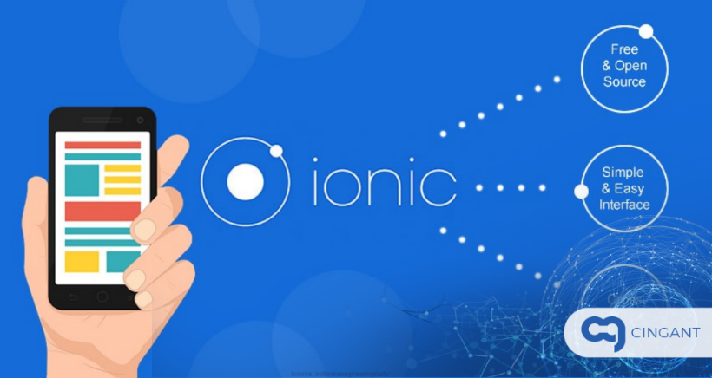

***Figure 1 – Iconic framework*** (Danis, 2018)

**Map Editor**

There is a variety of map editing tools available for use, for example, google API lets users design routes within the map in any location and allows developers to add features such as polylines, polygons, popups, etc; this provides developers with massive number of tools to make their map as detailed as needed. (Kalmanowicz, 2017).

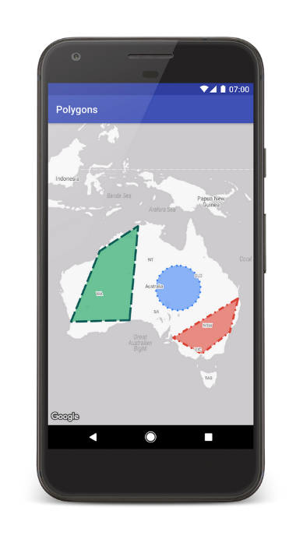

***Figure 2 – Google Map API editor*** (Kalmanowicz, 2017)***.***

Google now lets you store data objects with their markers now, they have extended their functionality to polygon and polylines as you can see in figure 2 above. This means that you can extended geometry objects to store any sort of data you require. You can now also store data on set of ground overlays and with each one you can store a database reference, using this the database it can contain real estate listings using URL clicks or listings of what anything you want. “You no longer need to manage your data associations to your mapping visualizations–nobody enjoys writing that code anyway. For example, if you supply a set of ground overlays showing home floor plans you could store a database reference with each one. The database can contain anything! It could hold real estate listings, and you could open one of those listing URLs on click.” (Kalmanowicz, 2017)

**Renting problems for young adults**

Alongside doing research for the project, I have made efforts to do research on the problems surrounding the project, how hard it is to find a desirable place to rent, issues regarding the high rental prices nowadays. On other hand people tend to rent more nowadays since the house prices are extremely high currently in many areas.

The landlords are even now refusing to rent to the young demographics in fear of rent not getting paid on time, fear of the property being destroyed or trashed. There is another case where too many young people are in receipt of either housing benefit or universal credit which hinders chances of finding a place go rent.

Landlords are refusing to rent their properties to young adults under the age of 35, scared that rents won’t get paid in time and contracts will be breached (Musaddique, 2017).

Research that has been done in university of Sheffield shows that around 30% of landlords have actively been wanting to change the letting strategy and some have changed their letting strategy already. Out of the survey done 32% have said that they plan to decrease renting out to young adults all under the age 35. While only 6% of landlords have said they are willing to rent their property to young adults under the age of 35 and hope to increase this within the next 3 years. This study makes some awful readings for the young demographics since, many are battling to survive with low or stagnant wages. Young people being on benefits like housing or universal credit really hinders any chance for them to find a place to rent and this is knock-on effect from wages being too low while living costs has increased.

The research also shows that 79% of the landlords said that the reason they have decreased renting to young adults under the age of 35 is because of the high risk from rent debt. A total of 68% mentioned higher risk of the tenancy condition getting breached.

The 4/5 of renters that said they would rent to the young adults under 35 only if as an additional security measure, the tenants are able to provide; use of guarantors and direct payments (Musaddique, 2017).

**House price inflation**

The house prices have been rising for a while now and they will not stop that soon, although in the past year house prices have stayed muted but in some areas the house prices have risen by 1 – 3 % and on the figure 3 below you can see what the house prices are predicted to rise by within the next 5 years.

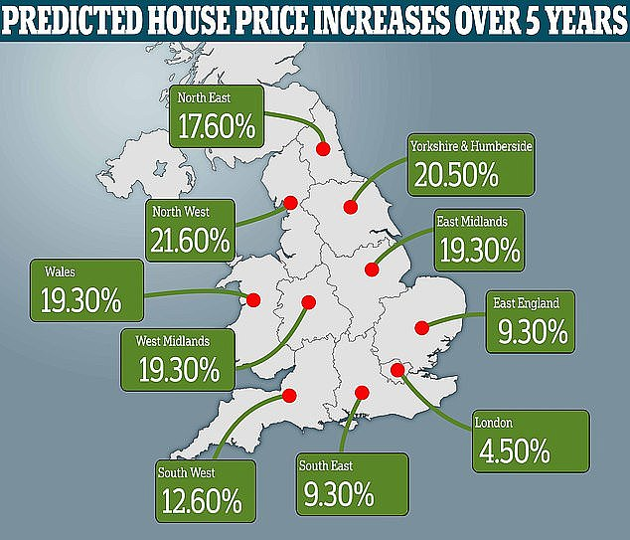

***Figure 3 – House price inflation*** (DailyMail, 2018)

As you can see there are few places with the increase in price; such as Yorkshire with 20.5% and some low areas in London, that will still rise by 4.5%.

The house prices not just in England but in the UK is increasing also, as you can see in figures 4 and 5, leaving the young adults to fend for themselves by finding landlords that will privately rent to them. Which is tough with low wages and no security if the landlord will kick you out without any substantial amount of time of notice.

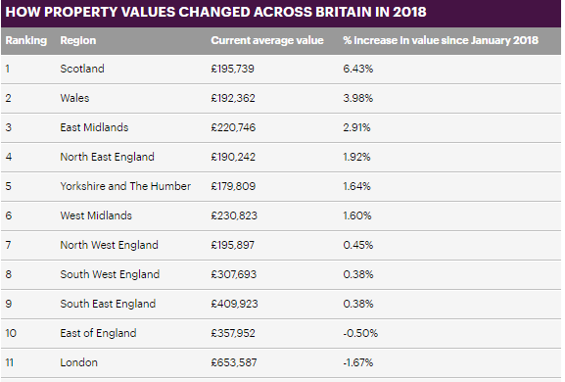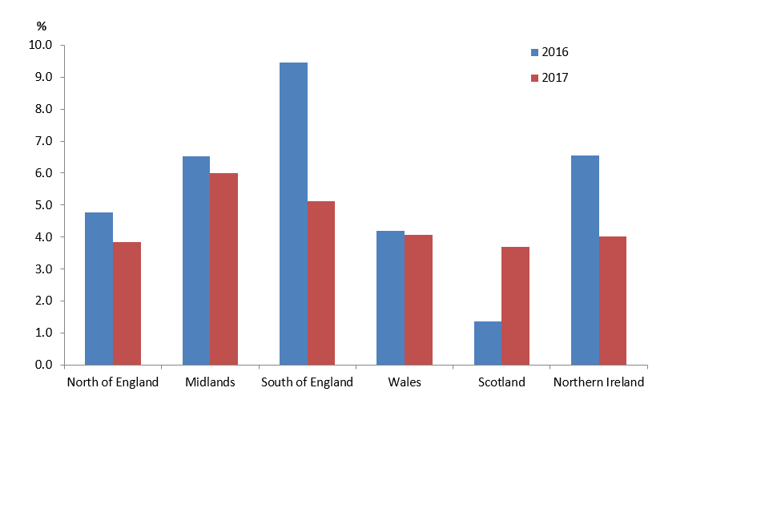

***Figure 4 – Property value*** (DailyMail, 2018)***. Figure 5 – Property value*** (HM Land Reg, n.d.)***.***

**Renters anxiety**

There are many that suffer from renter’s anxiety as it is known by. The millennials will never be able to own a home because of the rising price and property market crisis. Renters can be evicted at any time from the property they live in currently with just two months of notice. What affect does this have on one’s mental health you may ask?

A 30 year from Sheffield, named Brett chapman has lived in seven different houses in the past 10 years and has said that it is very stressful thinking about finding a place to rent especially if you have completed university. You can never make your home feel homely like you might want; since you cannot decorate it and you never know when you will have to leave the house to find a another one. Moving around every one or two years can be very intimidating.

Most of the young adults nowadays would need more than two hands to count the number of houses they have lived in since university and according to reports, a person has lived in 25 houses since graduating from university. Surely this has an adverse effect on a person’s wellbeing. This is what Chapman had to say from the stress caused by renting multiple times, “I struggled with depression when I was younger and my living situation was a part of that,” (Cosslett, 2019)

From a survey held the mental health charity mind had seen figures showing that almost 79% of young people had mental health problems due to the housing situation. The living situation either caused it or made their mental health worse. “figures showing that nearly 79% of people with mental health problems say a housing situation has caused a mental health problem or made their mental health worse.” (Cosslett, 2019).



## Literature Review Part 2 – Similar solution

There are currently some websites and applications out there that are loosely similar to the project but are not directly related to the problem area. Some of these websites and app are pretty standard that allow users to search for property to view but they are mostly used for property sales rather than focusing on renting and giving information about the area itself in much detail. Nowadays many websites have started to combine their websites to mobile applications; since using the new functionality plugins you can create hybrid apps that uses websites within the app itself.

In this part of the literature review the developer will compare some of these websites and apps to get a better understanding on the solutions that are used.

**Property Pal**

Property Pal is a good website which provides users with a variety of excellent functions such as searching for property to buy and now enabling users to search for property to rent. From the research of this solution, there are some similarities that can be drawn within this app and the proposed solution.



***Figure 6 - Property Pal App*** (PropertyPal, n.d.)

With property pal being well known before they started the app, they have substantial number of users and gaining above 10,500+ every hour. from reviewing the property pal website, it shows that the website is mainly used by users, estate agents, buyers and sellers for property use and not much for renting purposes since thy have just started to branch out to renters not so long ago. Property pal’s website design is professional, simple and elegant to the end user as you see in the Figure 6 above. Using the search criteria and the logging system to leave reviews is some of the features; that are similar to the proposed solution.

Overall the website is very well built and there are multiple features from this solution that can be taken into consideration for the proposed solution to enhance the end user needs. Once the project is complete and the mobile application is built the feedback section will be good to provide the developer with some insight upon how the proposed solution rates against other apps out there. In the table 2 below is the summary of property pal website

***Table 2 – Results of Property Pal***

|  |  |  |  |
| --- | --- | --- | --- |
| Design (1-5) | Functionality (1-5) | Navigation (1-5) | Notable Features |
| 3 | 3 | 4 | User profile, view the area and search for houses to buy or rent,  Can search for schools nearby. |

**Rent.com.au**

Rent.com.au is a very simple but elegant mobile application that is very similar to the project, it offers the user to search for homes to rent all over Australia. With over 100k download and 98,000 customers this app has become very popular from renters and I believe an app like this could benefit everyone across worldwide, since this app is only available to users in Australia.

The app uses the built-in function to help you find a place to rent fast, once you register and login to your account you can then enter in your resume which will be your personal renter resume for landlords to view. Your rental resume will be your own personal profile which will make you stand out as a renter and help you find a place that sooner. As you can see in figure 7 below the renter’s history is shown like a work resume.

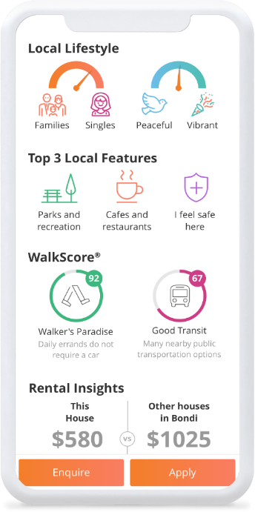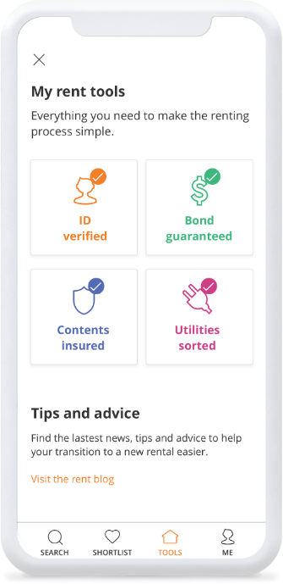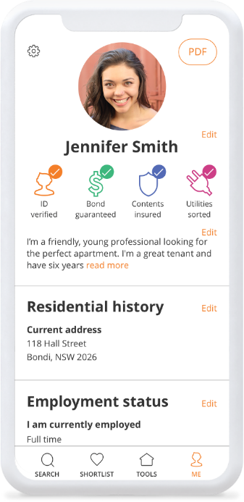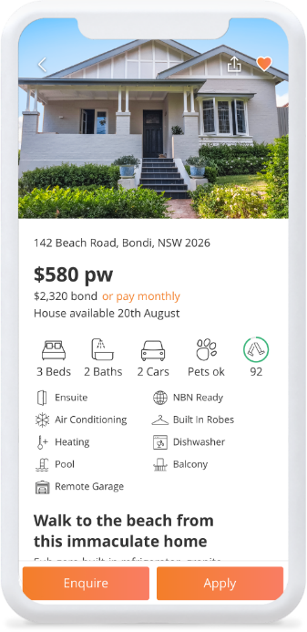

***Figure 7 – Rent.com.au App*** (Rent.com.au, 2019)

This solution is very good, it has a good design and relevant with many features. The app is supported for Android and iOS devices. The only limitations for this app is; that it is only available to users in Australia and it does not provide as much detail it should about certain areas. This limits user to know more about the area and its locality, since this is mainly focussing on getting users the house, they want to rent it is understandable. I would say this is the major difference between the solution and the proposed project.

Many elements from this solution can be incorporated for the proposed project since the design is extremely professional and uses current level features. The review section for this app is very useful also for the proposed project and will benefit the project in major way.

***Table 3 – Results for rent.com.au***

|  |  |  |  |
| --- | --- | --- | --- |
| Design (1-5) | Functionality (1-5) | Navigation (1-5) | Notable Features |
| 5 | 5 | 5 | User profile, view property fast, uses search function to search using users’ criteria, app for agents, renters and the landlord. |

**aspc Property Search App**

This app allows users to search for areas to rent or buy houses and it is localised only for Aberdeen. It is an app that is connected to Aberdeen estate agents to allow users direct communication. The applications design is very simple and generic, but the app could do better with an updated design and colour scheme. There is some great potential with this application, but it just does not fully use its capabilities. Apart from the simple design scheme the app has many negative reviews, mainly for not saving data from user’s search, every time the user opens the application, they need to re-enter their search criteria to find what they had searched for previously.

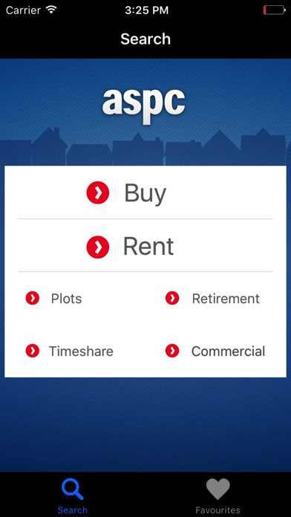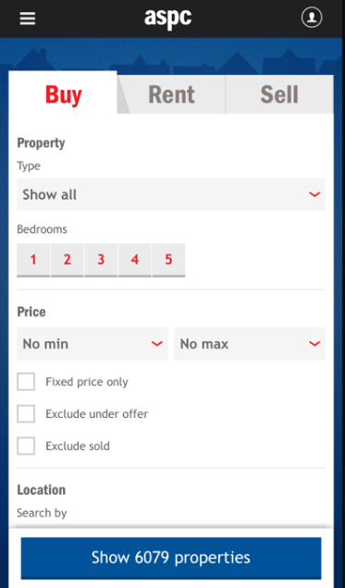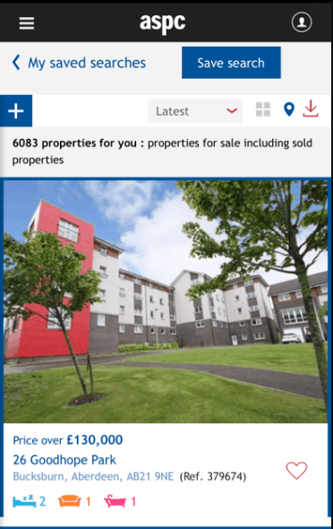

***Figure 8 – ASPC Property Search*** (aspcProperty, 2019)

The App does however offer some features that can be added to the proposed application, such as the search criteria, map API function, login functionality and it offers the user information about the area, population, sights of interests etc. However, the proposed app would provide more beneficial to the users and businesses than this app. The app has a section that provides users information about specific area’s locality which would be useful for the proposed solution and the feature can be improved further. This can be done simply by fixing the design layout and how the information is displayed to the user to make it more user friendly. Below in table 4 is the summary of aspc app.

***Table 4 – Results of ASPC Property Search***

|  |  |  |  |
| --- | --- | --- | --- |
| Design (1-5) | Functionality (1-5) | Navigation (1-5) | Notable Features |
| 2 | 2 | 2 | Search function, login/register function, detailed information about the area and its locality. |

**Zoopla app**

Zoopla is a very popular website for viewing properties to purchase, the website allows you to search for houses depending on the price, rooms, area etc and now they have an app which allows users to search for houses to buy or rent. When Zoopla first released their mobile app to iPhone/Android, in its first two weeks it had gained over 50,000 downloads and became the UK’s top property market app. The features within this mobile application is that, they allow users to search for many properties to buy, let or rent while on the go, it provides details with house prices dating back early as 1995, it has a new augmented function to view areas and a local market data analysis to allow users view the prices of properties in different areas. These features provide users with multiple benefits and some of these features are similar to the features that will be implemented within the proposed solution.

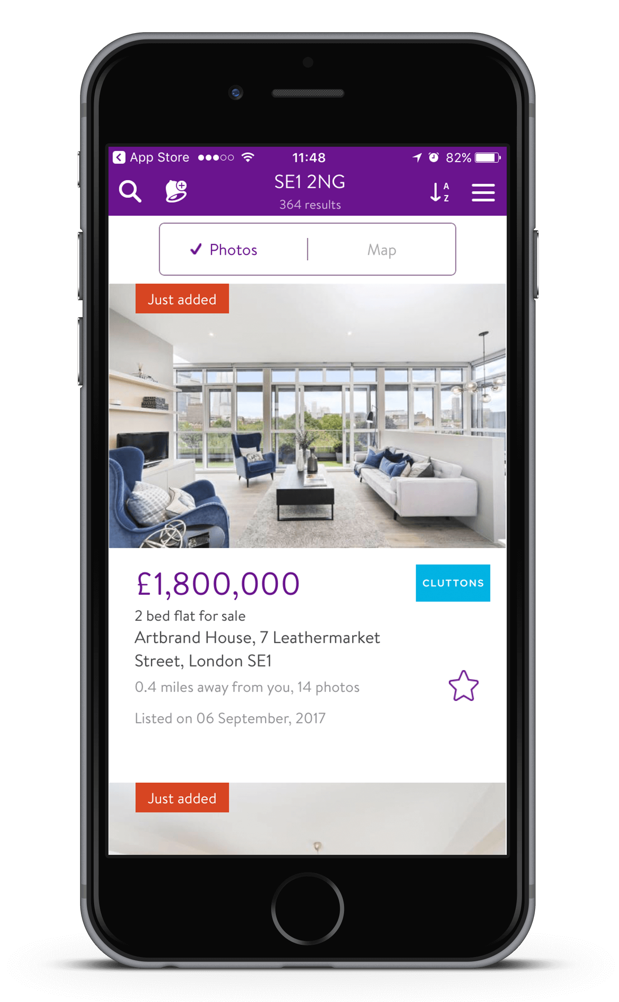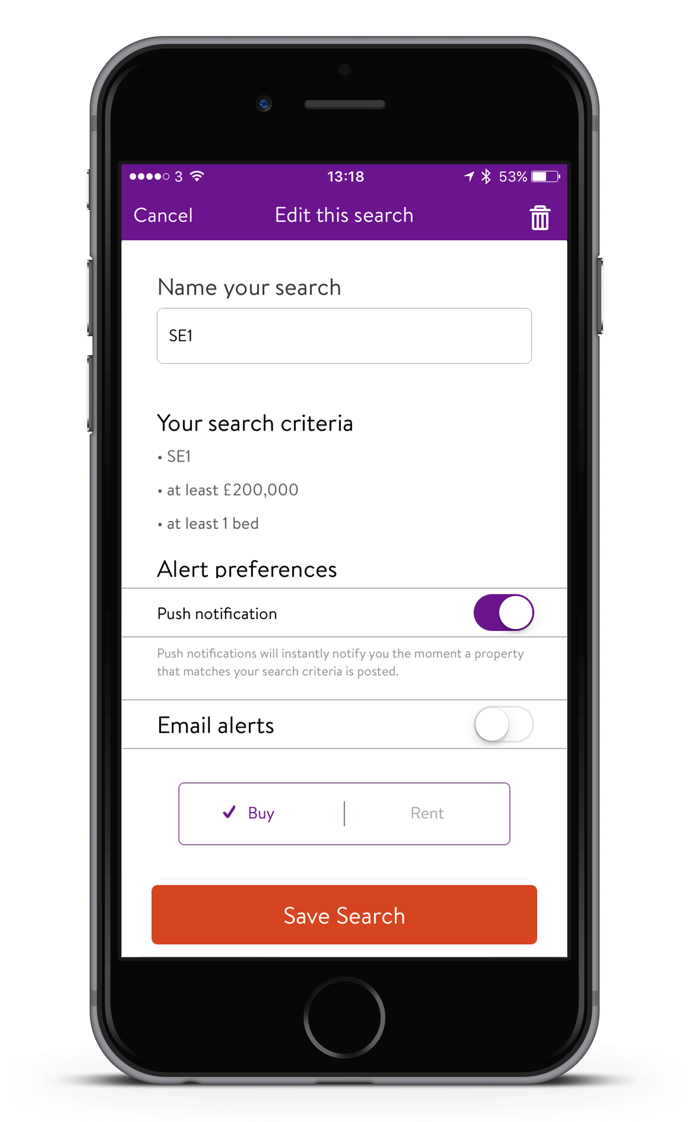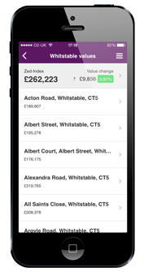

***Figure 9 – Zoopla app*** (Zoopla Limited, 2019)

The design scheme and layout could be better and compared to few other mobile applications that have been reviewed, in spite of that fact the app is very well built as you can see in figure 9 above. The main focus with these properties mobile application is that they focus on renting as well as house sales which divides their resources. The app provides details regarding the houses more rather than the area itself and information about the locality and public services (Zoopla Limited, 2019).

After researching some reviews for the mobile application, most of the consumer feedback was with the design of the mobile application and few features, in the table below are the summary of Zoopla app. Summary will take into account the design of the app, functionality, navigation and any notable features.

***Table 5 – Results of Zoopla Mobile Application***

|  |  |  |  |
| --- | --- | --- | --- |
| Design (1-5) | Functionality (1-5) | Navigation (1-5) | Notable Features |
| 2 | 3 | 3 | Display house prices for different areas using local market data analysis, uses search function to search using users’ criteria. |

**Results summary**

Below in table 6 it shows the summary of all the 4 apps that have been researched and ranked how well each is by overall score.

***Table 6 – summary of results***

|  |  |  |  |
| --- | --- | --- | --- |
| Solution Name | Relevance to Project | Size of business | Overall score |
| Property Pal | 4 | 5 | 5 |
| Rent.com.au | 5 | 5 | 5 |
| aspc Property Search | 3 | 2 | 3 |
| Zoopla | 4 | 4 | 4 |



# PROJECT PLAN AND REQUIREMENTS SPECIFICATION

## Stakeholder Identification

For this project I will have direct and indirect stakeholders as you can see below, the direct stakeholders will include the developer and the project mentor as they are concerned with the activities of the project and seeing it through to completion. The indirect stakeholders are the users of the demographic renting app since they are not directly affected by the project, their concern is only with the project once completed. As I have mentioned below my indirect stakeholders will include the renters and PSG who will test my app.

The following are identified as the direct and in-direct stakeholders in this project.

**Direct stakeholders**

* Nazrul Ali – Project Developer/ Tester / Designer / Manager
* Leo Galway – Project Mentor

**Indirect Stakeholders**

* Renters/Public that will use the demographic app – Users
* Peers – Users / Advisors / Peer Support



## Requirement Gathering Methodology

**Stakeholder meetings**

The requirements for this project will be gathered through various methods such as, peer support group, meetings with my mentor, crowd sourcing and via a survey that is completed by the users who will be using the app and renters. During the initial stage of the project, when meetings were undertaken by the direct stakeholders, the idea for a demographic renting app was conversed. In result this is where the first requirements were formed for the application.

**Brainstorming**

Another method, brainstorming was used to gather further ideas for the project from the peers, and each of the peers involved were treated as specific stakeholders. There are many techniques that can be used to brainstorm, you can brainstorm ideas just by yourself if you have to, you can try using business papers, news articles, trade journals and publications containing information about businesses. By researching through many business articles, you will have the ability to broaden your mind and develop more new product ideas. (Kyle, 2019)

Another technique that is used for brainstorming is the goodie bag technique. Goodie bag technique is where a group of small teams sort out few unknown items from a bag that is focused towards the company’s goal, from these items the teams then start writing down ideas as they happen. A company manager from Nestle’s Sunmark division participated in a goodie bag brainstorming task; for a new product development and has said they were able to come out in the end with various new ideas. “In the meeting, we divided the team into sub-groups of three to four people and gave each a bag. After digging through the bags, discussing, and writing down ideas, each group gave a small presentation. We came out of the meeting with many more great ideas than we could implement that year and it was fun for everyone involved.” (Kyle, 2019)

**Surveys**

From the initial requirements a survey will be created to gather information form indirect stakeholders. The survey will range from various valuable information such as, what is the most common mobile operating system used, do you currently rent, if so where do you rent and other features the indirect stakeholders recommend. To gather information from users the most efficient method used would be to send the survey to peer support group, friends, families and various businesses in different areas. As you can see in the figures below the summary of each survey question.

**Survey Results**

For the survey question, people were asked what operating system they use for their mobile applications and most majority of the survey takers have said they use Android operating system. By gathering this information, the developer will have the ability to decide what would be the popular OS to develop the app for. In the figure 10 below you can see the results from the survey, which 16 people participated in.

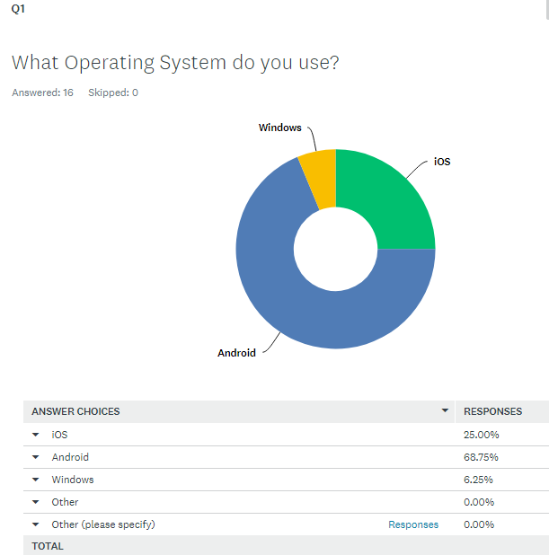

***Figure 10 – Survey result 1***

For the second survey question the participants were asked if they currently rent at the present time, so the developer can get feedback from first hand tenants. You can see the results in figure 11 below.

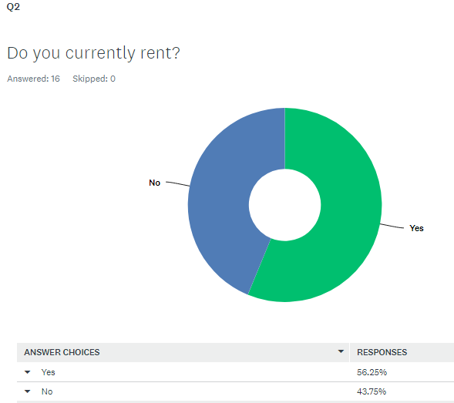

***Figure 11 – Survey result 2***

Question 3 of the survey, the participants were asked what area they live in, to get a demographic insight of the areas that can be included for the proposed solution by the developer. As you can see from the results of the survey below on figure 12, where the participants are from.

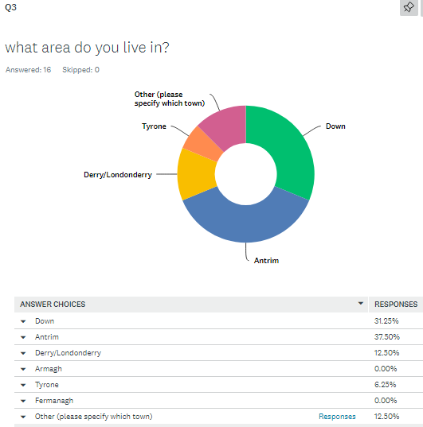

***Figure 12 – Survey result 3***

Survey question 4 was more of a follow up question from the previous question, if the participants did rent then the developer would like to gather information to know where they currently renting to gain an insight about different locations.

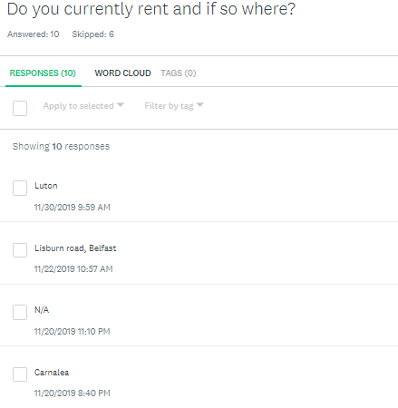

***Figure 13 – Survey result 4***

For question 5 participants were asked would they benefit from having a rent management app to help with their needs and most majority of the participants said yes, as you can see on figure 14 below.

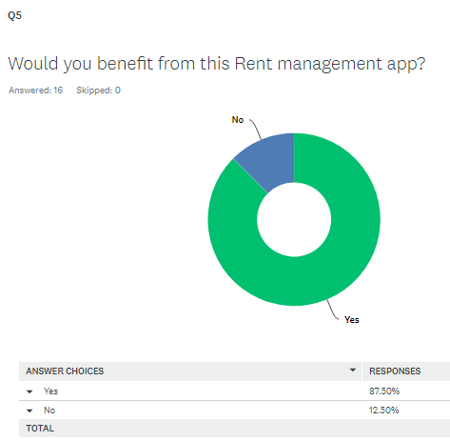

***Figure 14 – Survey result 5***

Question 6 is more for the developer to gain an idea of what the people will like to see in the app, what features they feel would be helpful for them as tenants or help them find places to rent quicker. From the results below on figure 15 you can see it is a mixed result, but the developer can use this result as to figure out what to include on the app.

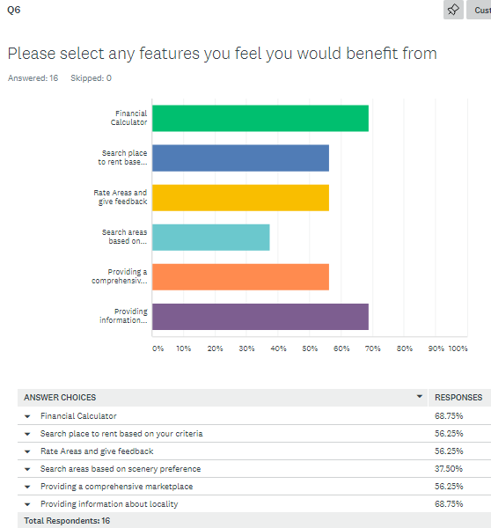

***Figure 15 – Survey result 6***

For question seven the survey was designed to engage the participants to express their feelings upon what is missing from the rental apps that are already out there. How can the developer make the users experience better by implementing which feature for the proposed solution and by looking at the results below, there are few good examples the developer can take into account when developing the app and include these features, such as the reviews from previous renters about the place, having trust worthy pictures of the area or the place, feedback from tenants and an feature that uses a system to calculate how much each tenant would pay if they were going to share the rental property.

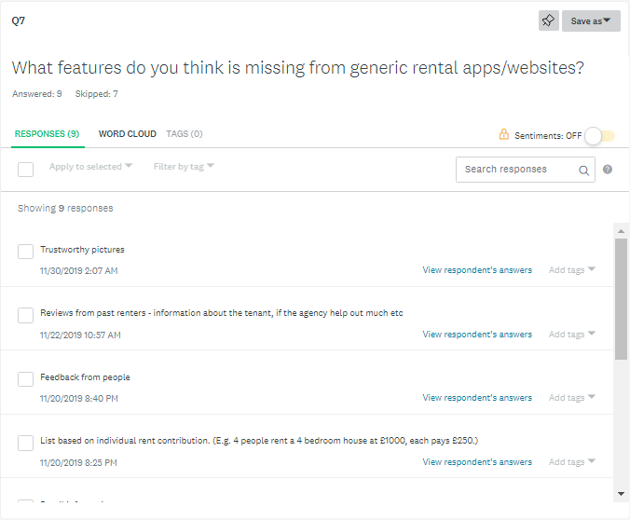

***Figure 17 – Survey result 7***

For the final question in the survey the participants were asked what feature would benefit the demographic app the developer is trying to make. The participants have said they would like to see feedback information, advice, which assuming would be for new renters as well as people already that are renting and etc. the full survey results can be seen in the appendix 3 section at the end of this report, as it contains all the answers the participants answered for questions 7 and 8.

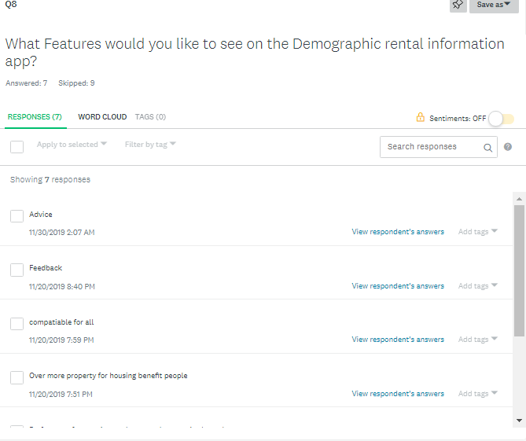

***Figure 18 – Survey result 8***

All the information gathered from indirect stakeholders through survey’s and brainstorming sessions should suffice with enough data to come up with a list of comprehensive collection of requirements to develop the demographic renting app. During the completion of the project, meetings with direct stakeholders will continue and if any new requirements are required then they can be implemented

## Prioritisation Strategy

The prioritisation strategy used for this project is relative weighting, since relative weighting is a prioritizing technique that takes into consideration of features that are present or absent for evaluation (bittenfeld, 2019) . Each of the requirements can get calculated bearing in mind the relative benefit, the penalty, cost and its risk. In other words, the relative benefit of the project and its users, the penalty if the final project was not able to implement its features, how difficult it will be to implement the requirements and how long it will take. The formula to calculate the measures of priority is:

***Priority = value % / cost estimate * weight of cost + risk estimate * weight of risk.***

The table 7 below will compare few requirements for the project and come to a decision. As a conclusion the database giving information about various area’s and its locality to the user is the most important requirement out of the few. In the table 7 below you can see the relative weights and each of the relative points are assigned from a value between 1 – 9. The table 7 below only show partial weighting of the requirements, the full relative weighting of prioritization table for all of the requirements is in the appendix 2.

***Table 7 – Prioritization relative weighting of Demographic app***

|  |  |  |  |  |  |  |  |  |  |  |
| --- | --- | --- | --- | --- | --- | --- | --- | --- | --- | --- |
| Relative Weights: | 1 | 2 |  | | 1 |  | 1 |  | | |
| Feature | **Relative**  **Benefit** | **Relative**  **Penalty** | **Total value** | **Value %** | **Relative**  **Cost** | **Cost**  **Estimate%** | **Relative**  **Risk** | **Risk**  **Estimate%** | **Priority** |
| Total Value |  |  | 87 | 100 | 24 | 100 | 33 | 100 |  |
| Provide user with information about different area’s & locality. | 8 | 9 | 26 | 29.8 | 6 | 25 | 8 | 24.2 | 0.605 |
| Display images of the area. | 5 | 6 | 17 | 19.5 | 5 | 20.8 | 7 | 21.2 | 0.464 |
| Provide users points of interests within specific areas. | 7 | 7 | 21 | 24.1 | 5 | 20.8 | 5 | 15.1 | 0.671 |
| The user can search for areas using search function. | 4 | 3 | 10 | 11.4 | 4 | 16.6 | 4 | 12.1 | 0.397 |
| Implement location tracker function to let user know where they are currently. | 3 | 2 | 7 | 8 | 3 | 12.5 | 6 | 18.1 | 0.261 |
| Provide user with a finance calculator to calculate budget. | 2 | 2 | 6 | 6.8 | 1 | 4.1 | 3 | 9 | 0.519 |

For the highest priority requirement, providing users information about the area and locality, was given a high weighting because it is tremendously important for the project and to the users. Without the information about the areas and locality , it will make it difficult for the user to get a clear understanding of how the area is and what sights, shops, schools etc there are within the areas, also without this important feature the app will not complete the project with its full requirements thus the relative penalty and relative benefit was given 8. The relative cost was given 5 since it will take some amount of time to gather information to provide the users with. The relative risk value given was 1 since it will not take much technical ability to implement this as it requires mostly of gathering information and inserting them into the mobile application.

The project will be following Kanban and Scrum approach which lets the project utilize scrum values when needed, continuous improvement and focusing on prioritization. With many of the requirements on this project are relatively complex, prioritizing is important and a suitable strategy to use which Scrumban methodology implements. We will talk about Scrumban methodology in the later chapters in detail in this document.

## System Requirement Specification

The following table contains the functional requirements and the non-functional requirements.

***Table 8 – Requirements for Demographic Rent App***

|  |  |  |  |
| --- | --- | --- | --- |
| Requirement number | Type | Requirement | Priority |
| F1 | Functional | The user will be able to create account and log into the app. | 0.511 |
| F2 | Functional | The user can search for areas by town, city Scenery etc. | 1.704 |
| F3 | Functional | The system will show map for users to select area from to view information. | 1.145 |
| F4 | Functional | The system will provide with detailed information about locality and the areas. | 0.506 |
| F5 | Functional | The system will provide user with multiple images for different areas once the user selects a location to view to see how the area looks like. | 0.510 |
| F6 | Functional | The user will be able to rate different areas from a rating of either 1-5. | 0.701 |
| F7 | Functional | The system will allow the user to see their current location. | 0.539 |
| F8 | Functional | Database to store information about user login details, information about area, locality. | 0.438 |
| F9 | Functional | The system will allow users to use a financial calculator to check if they have enough budget for various areas. | 0.300 |
| F10 | Functional | The system will provide users to select locations on map and provide with detailed information about the specific areas. | 0.450 |
| F11 | Functional | Access controls to allow user only access to their profile. | 0.572 |
| F12 | Functional | Provide user to use maps to plan routes using algorithm to find quickest commute to and from work from specific areas. | 0.272 |
| F13 | Functional | The user will be able to write reviews in detail about the area. | 0.335 |
| F14 | Functional | Admin will be allowed to update and delete information. | 0.852 |
| F15 | Functional | The user will be able to view rental prices of various areas. | 1.153 |
| F16 | Functional | The system will allow admin to store information. | 0.474 |
| NF1 | Non-Functional | The application will work on all android devices. | |
| NF2 | Non-Functional | The app should be tested thoroughly using various testing methods. At the verification stage, unit testing, integration testing will be used. For the validation stage, system testing and user acceptance testing will be used. | |
| NF3 | Non-Functional | The response times of the mobile app should be fast as possible to ensure fluidity within the screens on the app when navigating through different sections on the app. | |
| NF4 | Non-Functional | The user interface should be consistent in its design on each page of the app. | |
| NF5 | Non-Functional | Meet with stakeholders to gather requirements. Use multiple methods to gather requirements, conduct surveys, brainstorm with peers and use crowdsourcing. | |
| NF6 | Non-Functional | Add a help screen for inexperienced users. | |
| NF7 | Non-Functional | Design and implement an easy to use accessible mobile app, implement many test cases to ensure app runs with no errors. | |

## Software Life Cycle Methodology

The methodology to be used for this project will be Scrumban, a combination of Scrum and Kanban. “Scrumban is most commonly used in development and maintenance projects. In practice, both development and maintenance teams need many of the same skills. Development teams need a means of managing their entire development process, while maintenance teams must be able to make updates and repairs to faulty software.” (SmartSheet, 2019).

Scrumban is having the best of both Kanban and Scrum and it is used quite often as mentioned in the article above. Since I will be working on this project individually alongside getting help from peers and my mentor, I felt that using this methodology will benefit the project and keep it on track.

Since the project is individual it will be following the scrum and Kanban (Scrumban) methodology, since scrum is well suited from small teams and works well with Kanban system. Using Scrum, it will provide each member with predefined roles for each stage of the sprint plan and Kanban allows flexibility with no predefined roles, thus combining Scrum and Kanban (Scrumban) makes it suitable for this project. Also, Kanban allows any changes to be made mid-way through the project which makes it one of the least costly methodologies during the implementation stage. (Planview LeanKit, 2019)

By using Scrumban approach for the project, each of the requirements can be planned into the sprint, allowing the vital requirements to be applied first. This increases the chances for a fully functional app to be developed by the end of the project. It also ensures that the least required functions make it into the project by end of the project.

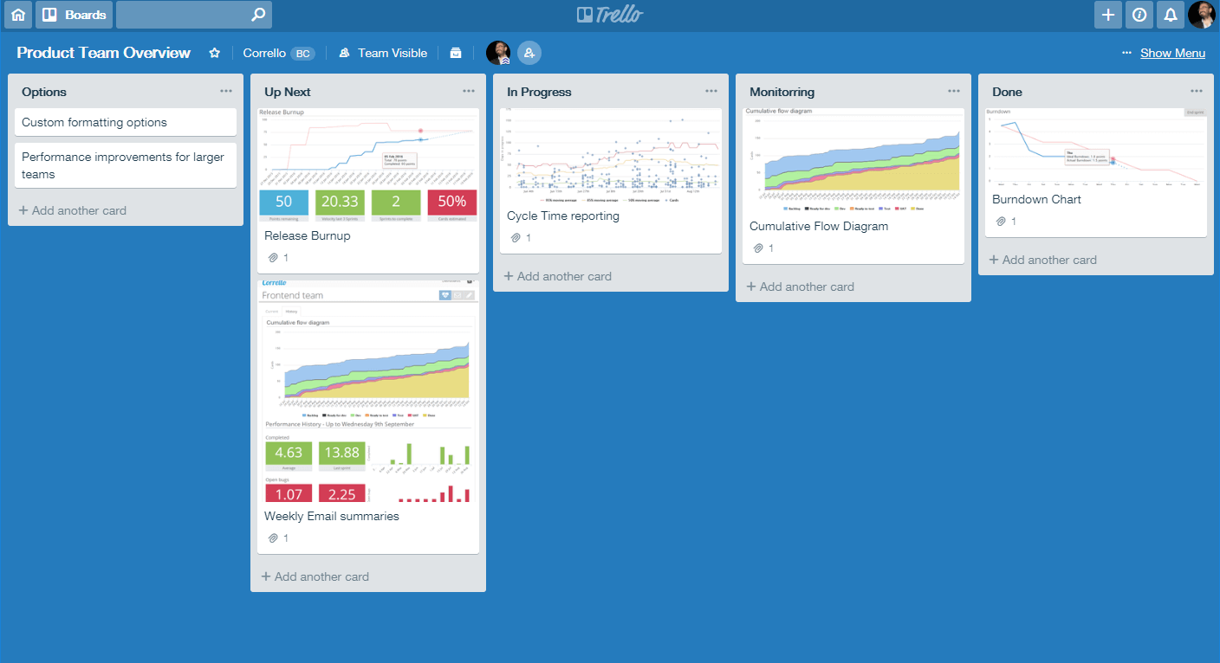

***Figure 19 – Scrumban Board*** (Trello, 2018)

Scrumban is a mixture of Scrum and Kanban, while Scrumban is an agile methodology is it there to help the scrum teams work with a new Kanban concept in the industry. “Scrumban is an Agile management framework, that is implemented when the teams opt for Scrum as the working way and use Kanban methodology as a magnifying glass to view, understand and carry out continuous improvement in the work.” (Knowledgehut, 2019).

## Implementation Plan

### Work Breakdown Structure

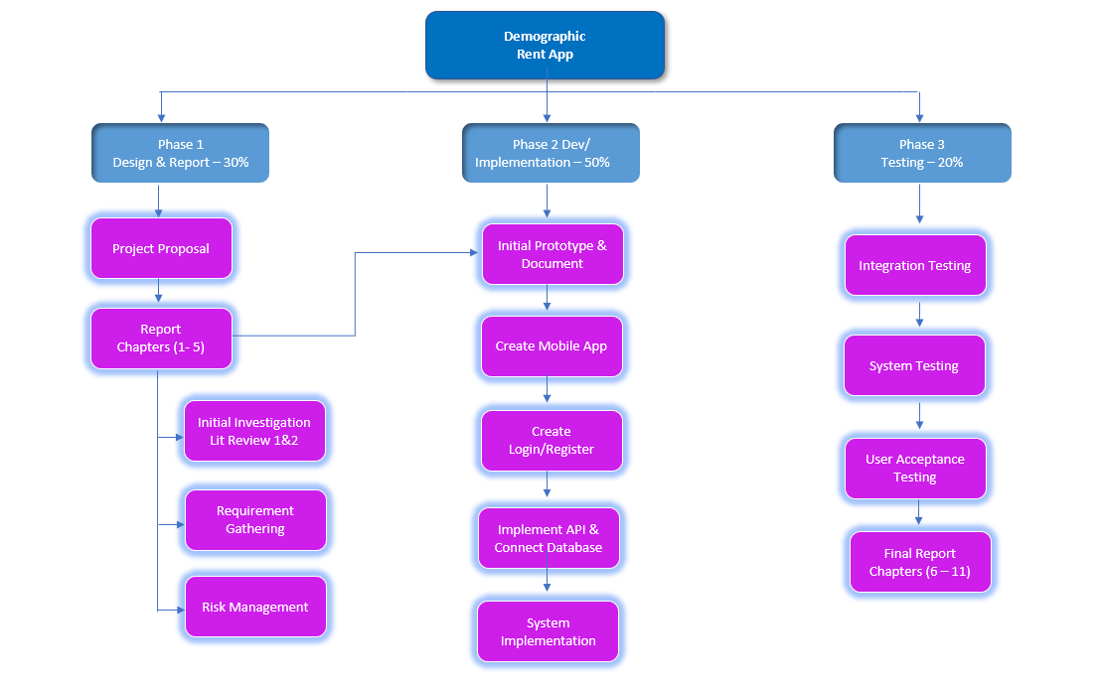

***Figure 20 - Work Breakdown Structure.***

**Effort Estimation**

In the table below, you can see the estimation of hours spent on effort for the project.

***Table 9 – Effort Estimation***

|  |  |  |  |
| --- | --- | --- | --- |
| Task | Item | Effort Estimation  Hours | Expected  Effort % |
| Entire Project |  | **400** | **100%** |
| Report |  |  | **30%** |
| - | Background Project Research | **20** |  |
| - | Initial Report (Chapters 1-5) | **40** |  |
| - | Final Report (Chapters 6-11) | **60** |  |
|  | **Report Total:120** |  |  |
| Development |  |  | **50%** |
| - | Build initial prototype | **40** |  |
| - | Development of Project | **160** |  |
|  | **Development Total:200** |  |  |
| Testing |  |  | **20%** |
| - | Testing | **80** |  |
|  | **Testing Total:80** |  |  |

### Gantt Chart

In the figure below you can see the partial Gantt chart created for the developer to follow. To view the full Breakdown with sprint plan for the Gantt chart, this can be found in the Appendix 1.

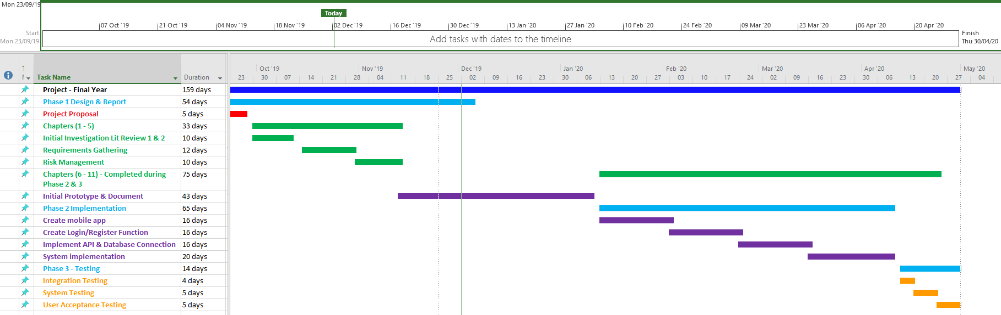

***Figure 21 – Gantt Chart of the Project Timeline***

**Phase - Design & Report -**

**Development - Testing -**

**Sprint Plan**

The following table will signify the sprint plan for the developer to follow, which will outline in detail what the functional and non-functional requirements are, and which requirement is included in which sprint. Also, will included the estimation of the amounted time that will be needed to work on each requirement.

***Table 10 – Sprint plan***

|  |  |  |  |  |  |
| --- | --- | --- | --- | --- | --- |
| Deliverable | Requirements  /Items | Work  Estimation | Total  Worked  hours | Estimated  Start Date | Due Date |
| Phase 1  Report | Background project  Research | 20 | 60 | 23/09/19 | 07/11/19 |
|  | Initial Report  (Chapters 1 - 5)  NF5 | 40 |
| Prototype AP1 | F16 | 10 | 40 | 07/11/19 | 03/12/19 |
|  | F14 | 12 |
|  | F6 | 12 |
|  | NF2 | 6 |
| Phase 2  Sprint 1 | F1 | 5 | 40 | 13/01/20 | 24/01/20 |
|  | F8 | 5 |
|  | F16 | 5 |
|  | F14 | 5 |
| Sprint 2 | F3 | 5 | 27/01/20 | 07/02/20 |
|  | F7 | 5 |
|  | F10 | 5 |
|  | F6 | 5 |
| Sprint 3 | F13 | 10 | 70 | 10/02/20 | 21/02/20 |
|  | NF6 | 5 |
|  | NF1 | 5 |
|  | F5 | 10 |
| Sprint 4 | F2 | 10 | 24/02/20 | 06/03/20 |
|  | F4 | 10 |
|  | F9 | 10 |
|  | NF3 | 5 |
|  | NF4 | 5 |
| Sprint 5 | F11 | 9 | 50 | 09/03/20 | 16/03/20 |
|  | F8 | 8 |  |  |
|  | NF7 | 4 |  |  |
| Sprint 6 | F12 | 8 | 23/03/20 | 10/04/20 |
|  | F13 | 5 |  |  |
|  | F15 | 10 |  |  |
|  | NF2 | 6 |  |  |
| Phase 3 | Final Report  (Chapters 6-11) | 60 | 60 | 13/01/20 | 24/04/20 |
| Testing | 60 | 60 |  |  |
| Overflow/  Improvements |  | 20 | 20 | 27/04/20 | 30/04/20 |

### Resource Identification

The shortage of resources hinders the development of project and it can lag behind the timeframe allocated. (Tutorials Point, 2019). As the project developer and manager, it is essential to highlight the resources required at the beginning of the project to ensure that all resources are gathered in due time to keep on track of the schedule that is planned.

To complete the project there are some resources that will be required. The following are the listed resources needed as you can see on figure 2: -

***Table 11 – list of resources***

|  |  |  |
| --- | --- | --- |
| Resources | Purpose | Type |
| Windows PC/Laptop | This will be required by the developer to create and complete the project. The developer will use this to complete the daily activities such as write-up of the project and the development of the project. | Hardware |
| Android Mobile Device | An Android device will be required for the developer to test the application on physical device to ensure the project is working as required. | Hardware |
| Android Studio | Android studio will be used for this project as it has built in emulator, IDEs and Frameworks to build, test and run the app. | Software |
| Git | Git will be used for backing up the project and be used in combination with the project for its source control purposes. | Software |
| APIs | APIs will be used for creating the maps that will be featured on this project. | Software |
| Firebase | The database that will be used for this project to store information on the app, also it will be used to store data for different locations. | Software |



## Verification Plan

Verification in general is the simple structures of a product requirements, design and system being verified ensuring that the requirements are met of the product. “whether it be rules on writing well- formed requirements, standards and best practices (external and internal) on the design, or requirements on the coding or manufacturing of the system.” (Wheatcraft, 2015).

As the project will be using sprint plans and Kanban approach, there will be testing at the end of each sprints. The multiple testing’s will be made of integration, system and user acceptance testing. For the first tests at the end of each sprint will be unit tests to ensure that every function can be performed on the application. By performing unit tests regularly, it will benefit the project as it will be less costly to uncover bugs during the unit testing stage rather than uncovering bugs at the user accepting testing stage, closer to the completion of the project.

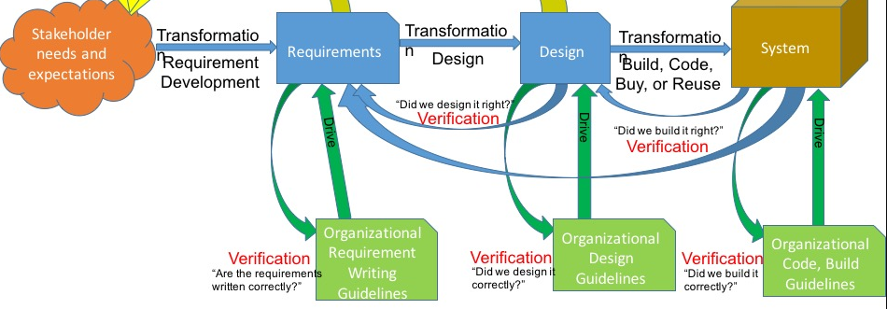

***Figure 22 – Verification Diagram*** (Wheatcraft, 2015)

**Integration testing**

Integration testing will be performed to test, that the features are integrated with the prototype. Integration testing is when unit tests are combined together and tested as a group. at the end of every sprint when new features will be added each time it is important to do integration tests to ensure that the current feature added has integrated successfully with the prototype. At the integration testing phase communication between the database and APIs will be tested.

**Unit testing**

During the development stage unit test are done to verify the accuracy of the codes. Unit testing are performed by the developers themselves rather than the testers. In unit testing a function or pieces of code is tested using drivers, stubs and mock objects. The unit tests are normally done automatically although manual unit testing can be done with the help of instructions and can be done to all types of web apps and mobile apps. It is crucial that unit testing should not be avoided, and developers should rather go for test driven development where themselves they will write the test for the code to be tested. Therefore, on basis of that test they will be able to write their code. (Murugan, 2019)

***Table 12 – Verification plan for Demographic rent app.***

|  |  |  |  |  |
| --- | --- | --- | --- | --- |
| Test ID | Test Description | Requirement  Tested | Expected  Result | Pass/Fail |
| 1 | App should load a login and register page. | 1 | The application should open a login/register page. |  |
| 2 | User proceeds to register an account with no information. | 1 | Should prompt user that registration value is invalid. |  |
| 3 | User proceeds to register an account with invalid information. | 1 | Should prompt user that registration value is invalid. |  |
| 4 | User registers with valid information. | 1 | Account should be completed successfully. |  |
| 5 | Attempt to log in with no information. | 1 | The user should be prompted that the information provided is invalid. |  |
| 6 | Attempt to log in with invalid information. | 1 | The user should be prompted that the information provided is invalid. |  |
| 7 | Attempt to log in with valid information. | 1 | The user should be able to log in successfully. |  |
| 8 | Search for areas by town. | 2 | The app should display the areas the user has entered. |  |
| 9 | Search for areas by city and scenery. | 2 | The app should display the areas the user has entered. |  |
| 11 | The system should show map for users. | 3 | The map function will load up for the user. |  |
| 12 | The system should show information about locality and the area. | 4 | The app shows information about locality and the area to the user. |  |
| 13 | Images should load up once user has selected an area. | 5 | Images load up on the app once user selects to view information of specific areas. |  |
| 14 | User can leave rating of 1-5 while logged out | 6 | The user should prompt the user to log in. |  |
| 15 | User can leave rating of 1-5 while logged in | 6 | The application should post the rating to the app for selected area. |  |
| 16 | The user can check and see their current location. | 7 | The app will use GPS function to locate user’s current location. |  |
| 17 | The Database will be able to store information about different areas. | 8 | Once data is entered it should get stored into the database. |  |
| 18 | The Database will be able to delete information about different areas. | 8 | Once data is deleted it should get removed from the database. |  |
| 19 | The Database will be able to update information. | 8 | Once data is updated on the database it should update the information showing the new data. |  |
| 20 | User should be able to use financial calculator to enter in their wages and outgoing payments to determine how much money they have for their budget to rent a place. | 9 | The financial calculator can calculate the in going and outgoing finance to give total of money left. |  |
| 21 | The user can select a specific location to get detailed information about the area. | 10 | The app will provide detailed information about an area once selected by user. |  |
| 22 | The user can only view their own account. | 11 | The app will implement access rights to ensure that only the specific user can see their own profile only. |  |
| 23 | The user will be able to use map API to plan routes and find quickest path. | 12 | The app allows users to use map API to allow the users to plan routes. |  |
| 24 | Leave a review while logged out. | 13 | The application should prompt user to log in. |  |
| 25 | Leave a review while logged in. | 13 | The app will post the review of the user. |  |
| 26 | The admin will be allowed to update information on the app and delete information that is not required to store in the database. | 14 | The Admin can delete the information when needed and update the information. |  |
| 27 | The user can view a location and view the rental prices of that specific area. | 15 | Once the user selects a location to see details, the details of the rental price for that areas should be displayed. |  |
| 28 | The Admin can add information on the app for the user to see. | 16 | The app allows admin to add information and in Realtime the data gets added. |  |

## Validation Plan

Validation is different from verification in that indication that it focuses more on the needs of stakeholders and defining if the project has met with the needs of the stakeholders. “Validation is concerned with demonstrating the consistency and completeness of design with respect to the user needs. This is the stage where you actually build a version of the product and validate against the user requirements.” (Guru99, n.d.). Design validation is a process that is done at the end of the project. Some of the design validation is done by comparing similar equipment that will perform and be used for similar purpose. “This method is particularly relevant for validating configuration changes for existing infrastructure, or standard designs that are to be incorporated in a new system or application.” (Guru99, n.d.).

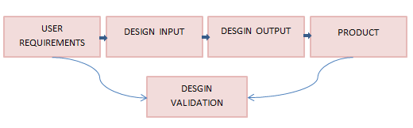

***Figure 23 – Validation diagram*** (Guru99, n.d.)

**System testing**

System testing is undertaken once the project has been fully implemented and developed to ensure if the project has met with its requirements. I have designed a table below that shows the example of system testing for the demographic rent app.

**User Acceptance testing**

User Acceptance testing Is done at the very end of the project and is the final phase of testing for the project. For this phase of the testing, users who are not directly involved with the project will be conducting the tests to ensure if the mobile application meets the user requirements and the user needs. This will determine if the mobile application is acceptable to be delivered and made available to the end users (Software Testing Fundamentals , n.d.).

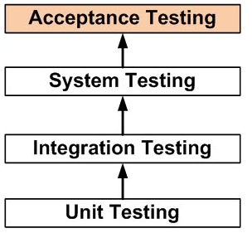

***Figure 24 – User Acceptance Testing Diagram*** (Software Testing Fundamentals , n.d.)

The users will use the mobile application with the following test to determine if the application meets the end user needs at this validation stage. The user acceptance testing will be done by the users at this validation stage by given each participant a questionnaire while they are using the mobile application. The following table show the questions that are included in the questionnaire.

***Table 13 – validation stage, tests for users.***

|  |  |  |
| --- | --- | --- |
| Question  ID | Question | Result  (Pass/Fail) |
| 1 | Can you create an account? |  |
| 2 | Can you log into the account once created? |  |
| 3 | Can search list of areas to choose from? |  |
| 4 | Can search and find information about locality and about the areas? |  |
| 5 | Can you enter an area or location and get information about the area, plus does the images load to give user an indication of the what the area looks like? |  |
| 6 | Are you able to leave a rating on the areas from 1-5? |  |
| 7 | Can you get your current location? |  |
| 8 | Can you use the financial calculator to find out you budget? |  |
| 9 | Can you see detailed information about specific areas such as, shops, schools, points of interests etc.? |  |
| 10 | Are you able to leave a review? |  |
| 11 | When you log in do you see just your account? |  |
| 12 | Can you go into a location and the area to see what the rental prices are in that specific area? |  |
| 13 | Does the application provide with points of interests to the user? |  |
| 14 | Does the application work on your android device? |  |
| 15 | Can you navigate from multiple screens to return to home page? |  |

The tests were designed to ensure that all the features that are required for the demographic rent app are tested by the users to uncover any hidden bugs that appear on the application, and if any bugs do appear then to fix them as soon as possible. By receiving feedback from the tests, it will help understand what features are working perfectly and what features needs tweaked slightly before the production of the mobile application. After the user will have finished testing the app, there will be few questions to get completed by the user, a questionnaire containing few open-ended questions.

***Table 14 - Questions users will get asked after using the application.***

|  |  |
| --- | --- |
| Questions | Answers (users will answer) |
| What feature did you like on the app? |  |
| What feature did you least like on the app? |  |
| Did you like the design on the mobile application? and, why? |  |
| Is there any feature you would add to the mobile application? |  |
| Is there any feature that you would like to remove from the mobile application? |  |
| Do you have any additional Comments you would like to add? |  |

It is good to ask open ended questions at the end of the project as it leaves the user to providing feedback about the application what they like and dislike. “do not limit users to one- or two-word answer. Instead, they have multiple potential responses” (Dube, 2019)

# PROJECT RISK ASSESSMENT

## Risk Assessment

***Table 15 – Risk Assessment***

|  |  |  |  |  |  |  |
| --- | --- | --- | --- | --- | --- | --- |
| Risk  ID | Risk | Threat | Control Measure | Likeliness | Impact | Risk  Level |
| 1 | Using a new framework and  programming language. | Unable to correctly implement  features. | At the beginning of the project allow time for research. | 3 | 6 | 18 |
| 2 | Hardware failure. | The project is impossible to recover. | Ensure multiple backups are made of the project. | 1 | 9 | 9 |
| 3 | The project not completed by deadline. | Few requirements not completed. | Create Gantt chart to help stay on schedule. Use Sprint plans. | 5 | 7 | 35 |
| 4 | Connecting the Database to store info for multiple locations. | Database not connecting to application. No Interaction between database to access and store information. | Address the issue of connecting the database early to ensure storing and retrieving information. | 7 | 9 | 63 |
| 5 | The project becoming more complex than first expected. | The project does not get completed by deadline. | If the features are causing issues, seek help from mentor or peers. | 5 | 8 | 40 |
| 6 | User interaction to login. | The user is unable to login to the app and add information. | Implement the required feature early to ensure the login functions are working. | 4 | 5 | 20 |
| 7 | Connecting the Map API to store information for each area. | Unable to connect and store information for each specific area, as required by the developer. | Do extensive research upon how to proceed with connecting the database to the Application then to the Map. | 6 | 8 | 48 |

**Risk assessment methodology**

There is a methodology used to evaluate the risks that can occur at different stages while completing the project, Probability risk assessment (PRA) is that methodology. The following formula is used to calculate the risk level:

**𝑅𝑖𝑠𝑘 𝐿𝑒𝑣𝑒𝑙 = 𝐿𝑖𝑘𝑒𝑙𝑖𝑛𝑒𝑠𝑠 𝑥 Impact**

The likeliness in the figure above refers to the probability of the risk happening during the project, I have assigned values between 1-9, with 1 being improbable of the risk occurring and 9 being highly possible. Impact refers to how much damage can the risk cause to the project if it were to happen, again I have ranked this from 1-9, 1 assigned to low impact upon the project and 9 assigned to having an immense impact to the project. (Ghia , Lloyd, Stenhouse, & Donev, 2015)



## Mitigation Strategy

**Risk 1:**

At the beginning there was short amount of time to do research into a suitable framework to build the Geographic Rent Info application. After choosing an unfamiliar framework, this also left me with re-learning the programming language and learning how to implement APIs that will be used to build the app, however in the Full-Stack Strategies and Development module this was being covered which combined with enough research this should be adequate to see the project through to completion.

**Risk 2:**

To prevent this, ensure there are multiple backups made of the project, ensure they are saved in different locations and use Git to regularly commit the project to the repository.

**Risk 3:**

Using the Scrumban methodology, it will ensure that during implementation the tasks are delegated and being worked on at every stage. At the end of every sprint a functional version of the application will be working. Using Scrumban, it will improve work across every stage of the project. By following a well-designed Gantt chart, it will help overseeing the project and keeping within the timeframe of the project to be completed before the deadline.

**Risk 4:**

The project will include multiple APIs, one is that it will provide a map, where the user can select to see information in specific areas. This information Is required for the project to succeed. At first the database needs to connect to the application to provide the information required. The initial prototype will implement the database CRUD functions to ensure connectivity between the database and the application. To mitigate the risk this must be worked early on as this is essential before moving on to the next stage of the project, the developer will conduct extensive research for each of the functionality that are required to understand how to implement them to be able to proceed with the project.

**Risk 5:**

By Attending the ‘Programming help’ lesion it should help solve any problems that is happening on the project. From all the combined mitigations for the other risks and by following a strict sprint plan it should give the project best chance to get completed before the deadline or the given timeframe. Assess the weightings of the importance of the requirements that are required for the project, discuss with the mentor and stakeholders to understand which requirements are needed for the minimum viable product.

**Risk 6:**

Implement the login feature early on to ensure the feature works. Create admin and customer logins, so that information can be logged and set up permissions to ensure only Admins have the features to insert, update and delete information on the app.

**Risk 7:**

To mitigate this problem with the connectivity of the database and map feature, there must be extensive research done to figure out solutions and alternative solutions. There are various ways to implement using the map feature to retrieve information from the database, one where a static map function gets used. multiple static maps can be used to imitate a real time functioning map.

# INITIAL FUNCTIONAL PROTOTYPE

## Risk to be assessed and Design Artefacts

By analysing the relative weighting model and the risk assessment that was produced for this project, the developer was able to make a decision on which risk will be high-level. The high-level risk will be the target for the initial prototype. In choosing the risk, the developer has focused on mainly mitigating the issue in the early stages of the project to ensure that the project will flow smoothly using the future sprints. For the initial prototype the developer selected the database needed to be implemented using the CRUD functionality.

All of the features that have been listed is requiring the need of a database, the requirements are dependent on a functioning database. Having the database in place will greatly increase the chances of developing the project and following the sprint plan made.

Taking the risk assessment table into consideration the database ranked highest in both likeliness and impact to the project, thus confirming the decision to mitigate the problem of connecting the database to the application early on.

The developer felt it would be appropriate to have a database working with the CRUD (Create, Retrieve, Update, Delete) functionality using real time database function. The presentation will include:

1. The app can Create and store data into the database.
2. The app can retrieve the data that has been stored into the database.
3. The app will be able to update the information as required.
4. The app will be able to delete the data that is not required to be stored on the database.

**Design Artefacts for the Initial Prototype**

**Json Schema**

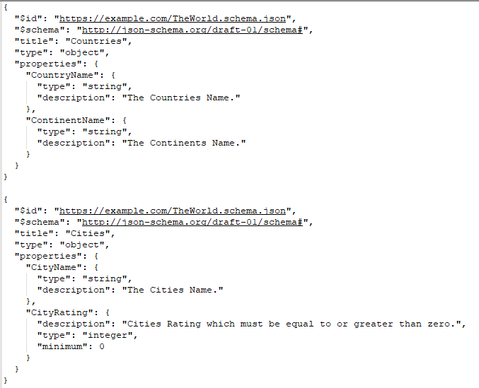

***Figure 25 – Json Structure***

This is the Json Schema used for the first prototype to store and retrieve information from the Firebase database. This comprised of what datatypes would be stored into the database when the developer will use the mobile application.

**Json Schema Data**

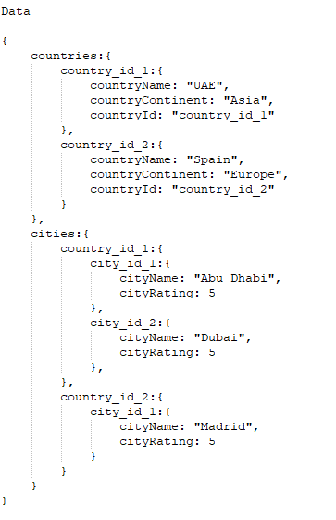

***Figure 26 – Json Data***

In the figure above you can see the Json data has used its schema to store in examples of data to the firebase database. This is the data that can be pulled in from the database to view, update or delete and using the Real-time database feature of firebase, the user will instantaneously see the data being manipulated. Each of the Json data and structure will change slightly during the later stages of the project development but for the initial prototype this is what the Json structure and data looks like.

**Wireframes of my prototype**

Wireframes are beneficial for any developer or designer as it helps outline the web or app project without getting diverted by trying to focus too much on colours, images etc. therefore for this project the developer has designed wireframes of outlining the two main screens the initial prototype app will use and its structures that the prototype will follow.

1. Add Country screen will be used to add a country to the database and the user will get to select what continent the country is in to store data into the database. Once data is saved on the database, the app will instantaneously retrieve the data and appear on the screen. From this screen the user will be able to click on the country names and either update or delete the information.
2. The Add City and rating screen will be used to store a city within the country the user selects from previous screen. There also the user will be able to leave a rating from (1-5) for the city 1 being a low rating while 5 being the highest rating.

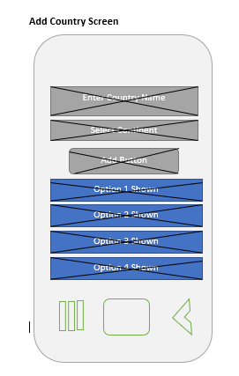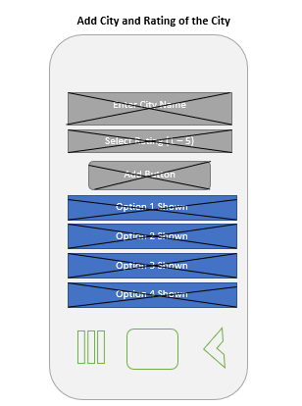

***Figure 27 – Wireframe of screen from initial prototype***

**Connection between Firebase and Android Studio**

Using firebase database, you can sync data between the mobile application and the database in Realtime. How it communicates with the app is, it stores/reads information on the cloud when the user creates, updates or deletes the data and then simultaneously notifies all connected devices to update their data.